ABC : A BREAD COMPANY
1FL., NO.105, SEC.1, AN-HO RD., DAAN DIST., TAIPEI 106, TAIWAN, R.O.C.
PACKING LIST
No. DI-60347 Date: MAR.30,2006
PACKIN LIST of MESH WIRE PRODUCTS (PURCHASE DATE:MAR.07,2006) Marks & Nos.:
DESCRIPTION:
For account and risk of Messrs. CHIEF-WELL COMPUTER CORP. N.W.:
3FL., NO.6, LANE 137, YEN CHI ST., TAIPEI, TAIWAN, R.O.C. G.W.:
MADE IN TAIWAN
R.O.C.
Shipped by CHIEF-WELL COMPUTER CORP.
Per EVER UBERTY V.WA227W Sailing on/about
From TAICHUNG TAIWAN To GOTHENBURG,SWEDEN
==============================================================================================
|Packing No.| Description of Goods | Quantity | NetWeight |GrossWeight|Measurement|
==============================================================================================
MESH WIRE PRODUCTS
PO#1118277-A
CY NO.TGHU4586155
1-4 #145188 MEDIUM 1-RUNNER PLATINUM @180 PCS @174.00 KGS @199.00 KGS @50.00 '
DI ITEM#993315209 720 PCS 696.00 KGS 796.00 KGS 200.00 '
MADE OF 83% MESH WIRE,10% STEEL
WIRE AND 7% EPOXY
1-12 #145288 MEDIUM 2-RUNNER PLATINUM @108 PCS @142.00 KGS @167.00 KGS @50.00 '
DI ITEM#993315219 1,296 PCS 1,704.00 KGS 2,004.00 KGS 600.00 '
MADE OF 83% MESH WIRE, 9% STEEL
WIRE AND 8% EPOXY
1 #135190 NARROW 1-RUNNER WHITE 270 PCS 230.00 KGS 255.00 KGS 53.00 '
DI ITEM#993315101
MADE OF 83% MESH WIRE,9% STEEL
WIRE AND 8% EPOXY
1-13 #145290 MEDIUM 2-RUNNER WHITE @108 PCS @152.00 KGS @177.00 KGS @50.00 '
DI ITEM#993315211 1,404 PCS 1,976.00 KGS 2,301.00 KGS 650.00 '
MADE OF 83% MESH WIRE, 9% STEEL
WIRE AND 8% EPOXY
1-6 #155290 WIDE 2-RUNNER WHITE @108 PCS @173.00 KGS @198.00 KGS @56.30 '
DI ITEM#993315311 648 PCS 1,038.00 KGS 1,188.00 KGS 337.80 '
MADE OF 83% MESH WIRE, 8% STEEL
WIRE AND 9% EPOXY
PO#1118277-B
CY NO.TTNU5039507
1-25 #145288 MEDIUM 2-RUNNER PLATINUM @108 PCS @142.00 KGS @167.00 KGS @50.00 '
DI ITEM#993315219 2,700 PCS 3,550.00 KGS 4,175.00 KGS 1,250.00 '
MADE OF 83% MESH WIRE, 9% STEEL
WIRE AND 8% EPOXY
1-11 #145290 MEDIUM 2-RUNNER WHITE @108 PCS @152.00 KGS @177.00 KGS @50.00 '
DI ITEM#993315211 1,188 PCS 1,672.00 KGS 1,947.00 KGS 550.00 '
MADE OF 83% MESH WIRE, 9% STEEL
WIRE AND 8% EPOXY
---------------------------------------------------------------------------------------------
TOTAL: 72 PALLETS 8,226 PCS 10,866.00 KGS 12,666.00 KGS 3,640.80 '
vv vvvvvvv vvvvv vvv vvvvvvvvv vvv vvvvvvvvv vvv vvvvvvvv vvv
SAY TOTAL SEVENTY TWO (72) PALLETS ONLY.
- THE END -
晉緯資訊股份有限公司
CHIEF-WELL COMPUTER CORP.
台北巿大安區延吉街１３７巷６號３樓
3FL., NO.6, LANE 137, YEN CHI ST., TAIPEI, TAIWAN, R.O.C.
TEL: 02-27317318 FAX: 02-27752816
PACKING LIST
No. DI-60347 Date: MAR.30,2006
PACKIN LIST of MESH WIRE PRODUCTS (PURCHASE DATE:MAR.07,2006) Marks & Nos.:
DESCRIPTION:
For account and risk of Messrs. ABC : A BREAD COMPANY N.W.:
1FL., NO.105, SEC.1, AN-HO RD., DAAN DIST., TAIPEI 106, TAIWAN, G.W.:
R.O.C. MADE IN TAIWAN
R.O.C.
Shipped by CHIEF-WELL COMPUTER CORP.
Per EVER UBERTY V.WA227W Sailing on or about
From TAICHUNG TAIWAN To GOTHENBURG,SWEDEN
Packing No. Description of Goods Quantity NetWeight GrossWeight Measurement
MESH WIRE PRODUCTS
PO#1118277-A
CY NO.TGHU4586155
1-4 #145188 MEDIUM 1-RUNNER PLATINUM @180 PCS @174.00 KGS @199.00 KGS @50.00 '
DI ITEM#993315209 720 PCS 696.00 KGS 796.00 KGS 200.00 '
MADE OF 83% MESH WIRE,10% STEEL
WIRE AND 7% EPOXY
1-12 #145288 MEDIUM 2-RUNNER PLATINUM @108 PCS @142.00 KGS @167.00 KGS @50.00 '
DI ITEM#993315219 1,296 PCS 1,704.00 KGS 2,004.00 KGS 600.00 '
MADE OF 83% MESH WIRE, 9% STEEL
WIRE AND 8% EPOXY
1 #135190 NARROW 1-RUNNER WHITE 270 PCS 230.00 KGS 255.00 KGS 53.00 '
DI ITEM#993315101
MADE OF 83% MESH WIRE,9% STEEL
WIRE AND 8% EPOXY
1-13 #145290 MEDIUM 2-RUNNER WHITE @108 PCS @152.00 KGS @177.00 KGS @50.00 '
DI ITEM#993315211 1,404 PCS 1,976.00 KGS 2,301.00 KGS 650.00 '
MADE OF 83% MESH WIRE, 9% STEEL
WIRE AND 8% EPOXY
1-6 #155290 WIDE 2-RUNNER WHITE @108 PCS @173.00 KGS @198.00 KGS @56.30 '
DI ITEM#993315311 648 PCS 1,038.00 KGS 1,188.00 KGS 337.80 '
MADE OF 83% MESH WIRE, 8% STEEL
WIRE AND 9% EPOXY
PO#1118277-B
CY NO.TTNU5039507
1-25 #145288 MEDIUM 2-RUNNER PLATINUM @108 PCS @142.00 KGS @167.00 KGS @50.00 '
DI ITEM#993315219 2,700 PCS 3,550.00 KGS 4,175.00 KGS 1,250.00 '
MADE OF 83% MESH WIRE, 9% STEEL
WIRE AND 8% EPOXY
1-11 #145290 MEDIUM 2-RUNNER WHITE @108 PCS @152.00 KGS @177.00 KGS @50.00 '
DI ITEM#993315211 1,188 PCS 1,672.00 KGS 1,947.00 KGS 550.00 '
MADE OF 83% MESH WIRE, 9% STEEL
WIRE AND 8% EPOXY
----------------------------------------------------------------------------------------------
TOTAL: 72 PALLETS 8,226 PCS 10,866.00 KGS 12,666.00 KGS 3,640.80 '
vv vvvvvvv vvvvv vvv vvvvvvvvv vvv vvvvvvvvv vvv vvvvvvvv vvv
SAY TOTAL SEVENTY TWO (72) PALLETS ONLY.
- THE END -
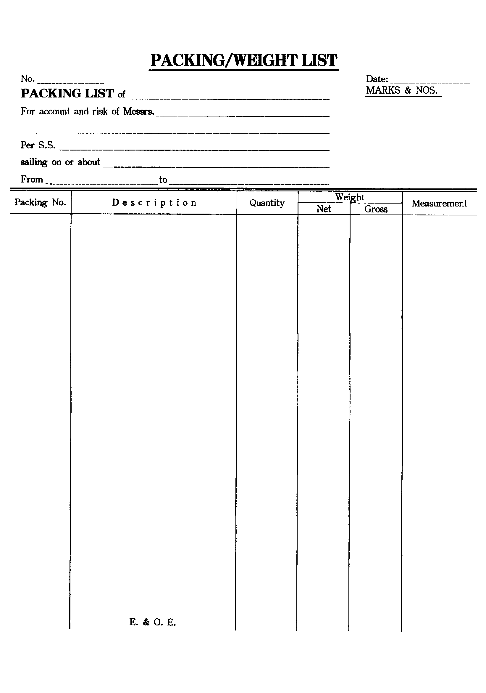
CHIEF-WELL COMPUTER CORP.
3FL., NO.6, LANE 137, YEN CHI ST., TAIPEI, TAIWAN, R.O.C.
TEL: 02-27317318 FAX: 02-27752816
DI-60347 MAR.30,2006
MESH WIRE PRODUCTS (PURCHASE DATE:MAR.07,
2006) DESCRIPTION:
ABC : A BREAD COMPANY N.W.:
1FL., NO.105, SEC.1, AN-HO RD., DAAN DIST., TAIPEI 106, TAIWAN, G.W.:
R.O.C. MADE IN TAIWAN
EVER UBERTY V.WA227W R.O.C.
TAICHUNG TAIWAN GOTHENBURG,SWEDEN
MESH WIRE PRODUCTS
PO#1118277-A
CY NO.TGHU4586155
1-4 #145188 MEDIUM 1-RUNNER PLATINUM @180 PCS @174.00 KGS @199.00 KGS @50.00 '
DI ITEM#993315209 720 PCS 696.00 KGS 796.00 KGS 200.00 '
MADE OF 83% MESH WIRE,10% STEEL
WIRE AND 7% EPOXY
1-12 #145288 MEDIUM 2-RUNNER PLATINUM @108 PCS @142.00 KGS @167.00 KGS @50.00 '
DI ITEM#993315219 1,296 PCS 1,704.00 KGS 2,004.00 KGS 600.00 '
MADE OF 83% MESH WIRE, 9% STEEL
WIRE AND 8% EPOXY
1 #135190 NARROW 1-RUNNER WHITE 270 PCS 230.00 KGS 255.00 KGS 53.00 '
DI ITEM#993315101
MADE OF 83% MESH WIRE,9% STEEL
WIRE AND 8% EPOXY
1-13 #145290 MEDIUM 2-RUNNER WHITE @108 PCS @152.00 KGS @177.00 KGS @50.00 '
DI ITEM#993315211 1,404 PCS 1,976.00 KGS 2,301.00 KGS 650.00 '
MADE OF 83% MESH WIRE, 9% STEEL
WIRE AND 8% EPOXY
1-6 #155290 WIDE 2-RUNNER WHITE @108 PCS @173.00 KGS @198.00 KGS @56.30 '
DI ITEM#993315311 648 PCS 1,038.00 KGS 1,188.00 KGS 337.80 '
MADE OF 83% MESH WIRE, 8% STEEL
WIRE AND 9% EPOXY
PO#1118277-B
CY NO.TTNU5039507
1-25 #145288 MEDIUM 2-RUNNER PLATINUM @108 PCS @142.00 KGS @167.00 KGS @50.00 '
DI ITEM#993315219 2,700 PCS 3,550.00 KGS 4,175.00 KGS 1,250.00 '
MADE OF 83% MESH WIRE, 9% STEEL
WIRE AND 8% EPOXY
1-11 #145290 MEDIUM 2-RUNNER WHITE @108 PCS @152.00 KGS @177.00 KGS @50.00 '
DI ITEM#993315211 1,188 PCS 1,672.00 KGS 1,947.00 KGS 550.00 '
MADE OF 83% MESH WIRE, 9% STEEL
WIRE AND 8% EPOXY
---------------------------------------------------------------------------------------------
TOTAL: 72 PALLETS 8,226 PCS 10,866.00 KGS 12,666.00KGS 3,640.80 '
vv vvvvvvv vvvvv vvv vvvvvvvvv vvv vvvvvvvvvvvv vvvvvvvv vvv
SAY TOTAL SEVENTY TWO (72) PALLETS ONLY.
- THE END -

